April 2016
Dear Friends and family in Christ
Greetings to you all in the name of Jesus.
Praise the Lord the rain has come. Truly praise the Lord for skin dry to the touch, for dry clothes when simply boiling the kettle or taking water from the fridge, for feeling a coolness and almost freshness at 7am and a shiver under the cold shower at night leading to a welcome sheet over you in bed. A warm very brief hug can become a gesture of love without the sweaty hand prints! These are the delights of the rainy season. How do we adequately describe these simple actions which turn our energy sapping city existence into joyful kingdom living. These first few months of 2016 have been an uphill struggle. Lent has been a time of persevering and persisting, acknowledging that we are not alone and that our weakness can make room for God’s strength but at the same time feeling disabled by the nature of the circumstances that dictate our actions. Returning time and time again to his promises allows us to truly believe and have faith that we are on the winning side. But this year has been one of the hardest of our 16 years serving with CMS.
Thankyou all for your prayers through this period and your emails and encouragements. As you will already know this is our last rainy season in Dar. The last lot of bajaji rides through rivers which moments before were roads. Our last lot of ceilings falling in and mattresses being soaked. Our last 6 hour journeys to the bank, 10 minutes down the road and our last walking with or without flip flops as a pose to ruining your shoes. Manchester will be sometimes similar but never the same level of unpredictability!
Many of you have asked how you can pray as we just have two months left now in Tanzania. Our prayer requests are many but not just for the packing up, handing on and saying goodbye. Our needs I am sure will be just as acute when we return and start to live again in UK without the incentive of knowing we would be back in the sun within 8 weeks. Please remember us post June when we leave and in the first few months of being in Manchester and reacquainting ourselves with our English daughter who we have missed a lot. We hope to start visiting churches from September with or without all 3 children. Grace is teaching us how having an almost 18 year old daughter works with study schedules, university visits and volunteering. This will be a different sort of culture shock within our family to go with the other culture shock in reverse. We will appear weird and out dated. We will be very politically incorrect and not even realize. We will ask questions in embarrassment about very simple things. We will be flummoxed and overwhelmed and will plead T.M.I when trying to connect the gas or the water or the electricity. We thank God that you will all be praying for this period of adjustment and that it will be short. We thank God for the Aldi’s of this world.

We have said goodbye to our kids at St. Monica’s Anglican Church. Many nice words were said and we were surprised and overwhelmed with the church’s gifts and expressions of gratitude. If only they had said these things to us whilst we were battling with the apparent lack of interest in us or in their own children. We were able to ask for encouragement for the team of 5 who now stand in front of 80 or so children every week. 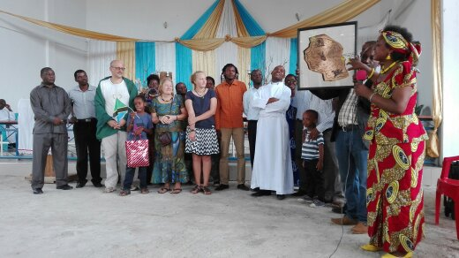
1 Gifts galore at the final farewell from St Monica's
Please pray that they will encourage and stand with those nervous men and women who have stepped into our shoes and with yet another new Pastor. Pray that they will value their children’s spiritual growth, not just teaching them the right words to say at the right time and the right symbolic actions to do at the mention of Jesus’ name, but recognising the whole church’s role in nurturing a relationship with Jesus. We miss them already but value the extra time and variety now on a Sunday morning. We have even worshipped at 6.30am in St. Alban’s Cathedral in the centre of town and experienced a completely different side of Dar in the early hours before the hundreds of buses roll in and deposit hundreds of people which need hundreds of snacks at the bus stops and hundreds of mobile tea units and hundreds of handkerchief stalls to cater for their hundreds of needs for the day ahead!
Simon has 1 more meeting at school followed by a Board retreat and then he leaves the HOPAC School Board for ever and there will be a huge sigh of relief from us all, the hardest job he has had to do here in Dar Es Salaam. Under Simon’s leadership the Board has changed considerably and has been able to guide the school through a very low patch into a more stable and therefore more productive period. He has chaired over 30 Board meetings and 150 special committee meetings. Over 180 times Simon has begged for shorter meetings! With as many as 6 or 7 nationalities in the meetings there has been much agreement and disagreement, misunderstanding and no understanding, frustration and relief. Always with the same goal of working towards offering a Christ centred education which equips students to live out a biblical world view in all areas of life. If this sounds exciting and a wonderful God given challenge for you please contact us as the Director urgently needs to recruit a range of teachers for August this year, English, Art, Sports, Special Needs and Maths….to name a few. There’s that coming out of an AC classroom , facing the bluest of Indian oceans and the tropical swaying of coconut trees, as you saunter to another AC classroom. Of course you can live like that Monday to Friday but then opportunities to get involved in the lives of ordinary local people are many, varied and equally as rewarding.
2 James Winning the 5k race in his age group

Staff at Buguruni Anglican Health Centre are bemoaning the fact that Simon is soon to go and doubting that they will be able to manage without him. But the last few months have been spent teaching and handing over and Simon is confident that there is a real competence there without the confidence in themselves and in each other. 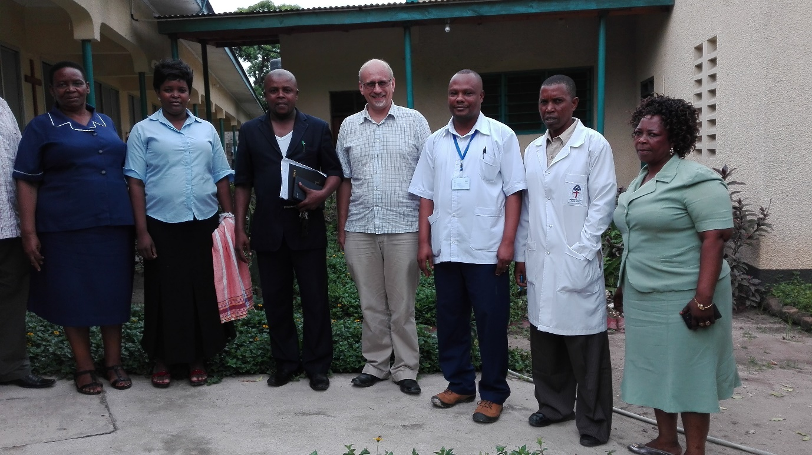
3 Staff at the health centre with the local council leader
This is something to pray about, that this spirit of helplessness will be destroyed and the staff will recognise each other’s abilities and trust each other and work together with the same goal of offering a loving and caring service to their patients. Simon in true Simon style is just installing a new electronic hospital management system which the staff need to be inducted in. Please pray for them as they learn how to use it and pray that it is successful in eliminating any loopholes in the system which can be exploited.
We thank God that Simon’s handing on is more straightforward than Laura’s at the Workshop. He has thinking and planning space in his head and is active in moving our family out of one life into another. Just this morning we paid a visit to the Forensic Bureau to have all of our fingers printed twice, to check we have no criminal charges pending…if we did have, the chances of the officers finding the paper work in the mountains of bundles that cascaded around the cobbled together office furniture, would be low….very low! So we would have left the country!
The Nuru Workshop is still in need of much prayer as is the Committee and the Imbaseni Trust over it. We are waiting for a response from the Ministry of Law and Justice who were responsible for registering the workshop under a different organisation, with our name but a different group of people as the Trustees. We pray that they will overturn this and without delay. Our Trustees are looking to secure the title deeds for the plot which currently are in the hands of the Pastor next door who will not surrender them. Please pray that the Imbaseni Trust will remove this man from their Board of Trustees at their next meeting. Pray against letting him continue to destroy what others have built up over the years. Pray for our guys at the heart of this awful conflict, in contact with this man daily , that they would continue to trust that God will bring justice for them and peace and grace to this man. Pray for Adam who does all the running around to these government offices. Pray against weariness and frustration for him.
We thank God that we have someone to hold the fort while we continue to ask God for a permanent Manager. Emmi who has supported me in my role as Manager will stay in Dar Es Salaam with her family for the next two years and so will continue at Nuru. She will hold things together while God calls and prepares someone to come. Please pray for that someone and pray for Emmi who is fearful of her abilities. Please pray for the committee as each person will take on a new role in order to keep things on the ground running smoothly.
We look forward with anticipation to what God will do to bring peace and hope back to this site. We lift up Esther, who will take on even more responsibility to help Emmi, and her hope to marry Davidi, her little boy’s Father , in June. We want to see it happen and rejoice with them as their story has not been easy at all. Davidi’s friends have said they will not attend as they do not agree with an able bodied man marrying a disabled and wheelchair bound woman. Their wedding on 11th June will be a victory in so many ways and be an encouragement to us all. We pray for God’s provision for them for the day and their new life together. Pray God’s blessings pour out on this couple. Thankyou.
For many of us we have our teenagers studying till late at night preparing for exams. Esther starts tomorrow with Maths, Grace in two weeks. Both have worked very hard and we would like God to honour them for their hours of study. We pray that they will receive what they desire and be able to witness to God not letting them down but preparing the way for them. James will be 9 in two weeks. He is less enthusiastic about leaving Hopac and friends, as is Esther. He is worried that he will not fit in, as is Esther and that people will laugh at his Americanisms and his past tenses…or lack of. We reassure him that out on the football pitch, those things are not important and everyone is equal. The fact that Man United will be playing just up the road also helps that adjustment to what’s happening in June.
So with 8 weeks to go please pray the time goes slowly and there is plenty of time for the most important things which are saying goodbye to friends and being able to thank God for the blessings that he has poured out on us in our 16 years of ministry here and thank those people who have helped us to see his hand always protecting and guiding us.
Please do consider the vacancies at HOPAC and at the Nuru Workshop ……
With our love and gratitude for your faithfulness to us in prayer and for your giving financially over these 16 years. We will be supported by CMS until beyond September when we start our four months of visiting our churches in UK. We will be in touch……..
In His service and thankful for that privilege
Laura, Simon, Esther, James and Grace in Manchester
xxxxx

